**CHAPTER 3**

**SYSTEM DESIGN**

This chapter focuses on the design of the database.

**3.1 Table Description**

**3.1.1Usertable**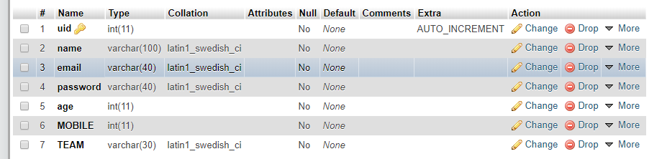 Fig 3.1.1 user

In the above fig 3.1.1, There are 7 attribute where Primary key is uid(user id) which is auto-increment and Foreign key is Team.

**3.1.1Batsman table**

